DE–7651
11
DISTANCE EDUCATION
M.Sc. (Physics) DEGREE EXAMINATION, DECEMBER 2009.
CLASSICAL AND STATISTICAL MECHANICS
(2008 onwards)
Time : Three hours Maximum : 100 marks
Answer any FIVE questions.
Each question carries 20 marks.
- (a) State and explain D-Alembert’s principle.
(b) Give Hamilton’s principle.
(c) Deduce Hamilton’s principle from D-Alembert’s principle.
- (a) Explain virtual work.
(b) Derive Lagrange’s equation of motion.
(c) Obtain the Lagrange’s equation of motion for
non-conservative system.
- (a) What are cyclic co-ordinates?
(b) State and explain the principle of least action.
(c) Obtain Hamilton’s equation of motion from variational principle.
- (a) Give a brief account on canonical transformation.
(b) Show that Poisson bracket is invariant under canonical transformation.
(c) Discuss the Kepler problem in action-angle variables.
- (a) Write a note on Euler’s angle.
(b) Give an account of angular momentum of a rigid body.
(c) Obtain Hamilton-Jacobi equations.
- (a) What are normal co-ordinates?
(b) Obtain the normal modes of vibration of a linear triatomic molecule.
(c) Discuss the different modes of vibration of a linear triatomic molecule.
- (a) Explain micro canonical ensemble.
(b) What is partition function?
(c) State and prove Liouville’s theorem.
- (a) What is grand canonical ensemble?
(b) Give a note on most probable velocity.
(c) Discuss Maxwell-Boltzmann statistics in detail.

———————
DE–7652
12
DISTANCE EDUCATION
M.Sc. (Physics) DEGREE EXAMINATION, DECEMBER 2009.
MATHEMATICAL PHYSICS
(2008 onwards)
Time : Three hours Maximum : 100 marks
Answer any FIVE questions.
Each question carries 20 marks.
- (a) State and prove Schwartz inequality. (8)
(b) Find the eigen values and eigen vectors of the
matrix 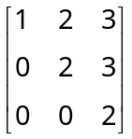. Can it be diagonalised? (8)
(c) Give the properties of vector space. (4)
- (a) State and prove Cayley Hamilton theorem. (8)
(b) Find the orthogonal and orthonormal set of vectors for the given set of vectors using Gram-Schmidt’s orthogonalization process 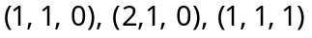.
(8)
(c) Show that 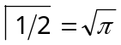. (4)
- (a) Prove that 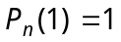 and 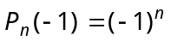 using the generating function. (4)
(b) Write down the Legendre differential equation and hence find its solution. (10)
(c) Prove that 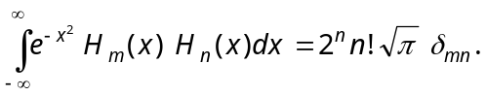 (6)
- (a) State and prove Cauchy integral theorem. (5)
(b) Find the Fourier transform of
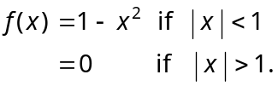 (7)
(c) Apply Cauchy’s theorem of residues to evaluate 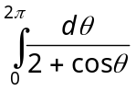. (8)
- (a) Find the Laplace transform of
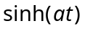 and 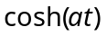. (6)
(b) Calculate the Fourier sine transform of 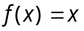 such that 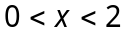. (7)
(c) Evaluate 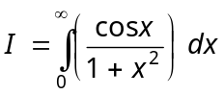. (7)
- (a) Write Laplace equation in Cartesian co-ordinates and explain. (4)
(b) Obtain one dimensional heat flow equation along a bar in the form
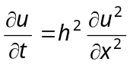. (8)
(c) Investigate the motion of taut string plucked at its centre. (8)
- (a) Explain about contraction of tensors and metric tensors. (4)
(b) Work out the character table for the symmetry of an equilatral triangle. (10)
(c) If 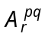, and 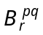 are tensors, prove that their sum and difference are tensors. (6)
- (a) Show that 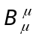 is a scalar where 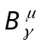 is a mixed tensor. (5)
(b) What are reducible and irreducible representations? Explain. (7)
(c) Construct the character table for 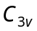 point group.
(8)
———————
DE–7653
13
DISTANCE EDUCATION
M.Sc. (Physics) DEGREE EXAMINATION, DECEMBER 2009.
INTEGRATED AND DIGITAL ELECTRONICS
(2008 onwards)
Time : Three hours Maximum: 100 marks
Answer any FIVE questions.
Each question carries 20 marks.
- (a) Explain class A power amplifier. How power is distributed in it. (6)
(b) What is an audio power amplifier? Explain the difference between a voltage and power amplifier.
(6)
(c) Describe the working of Push Pull Amplifier. (8)
- (a) Explain the working of source follower amplifier in a FET. Calculate its voltage gain. (10)
(b) Write a note on various types of biasing in FET. (5)
(c) What are the performance quantities of power amplifiers? Explain. (5)
- (a) List the characteristics of an ideal Op-Amp. (4)
(b) Draw the schmatic diagram of an ideal inverting Op-Amp. Calculate its gain. (7)
(c) Explain how the differential equation is solved by Op-Amp with suitable example. (9)
- Explain the working of Op-Amp as
(a) Differentiator. (6)
(b) Integrator. (6)
(c) Comparator. (8)
- (a) Give an example of a truth function using NAND and NOR functions. (6)
(b) Prove that 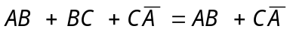. (6)
(c) Simplify the following Boolean function in sum of products using K map
. (8)
- State and prove De Morgan’s theorem. (6)
Explain the operation of
(a) J-K Master slave flip-flop. (7)
(b) Mod Counters. (7)
- (a) Explain the internal architecture of 8086 p and discuss the function of different blocks. (10)
(b) Name the different groups of instruction set of
p 8085 and explain. (5)
(c) Explain the use of relative addressing mode in a p. Give example. (5)
- (a) Write a detailed account on fabrication of monolithic Ic’s. (8)
(b) Write a note on Hall effect. (4)
(c) What are solar cells? How they are fabricated. (8)
–––––––––––––––
DE-7654
14
DISTANCE EDUCATION
M.Sc. (Physics) DEGREE EXAMINATION, DECEMBER 2009.
ELECTROMAGNETIC THEORY
(2008 onwards)
Time : Three hours Maximum : 100 marks
Answer any FIVE questions.
Each question carries 20 marks.
- (a) Write down Maxwell’s equations in differential and integral forms. (6)
(b) Point out the physical significance of each. (4)
(c) Discuss the propagation of plane electromagnetic waves in an isotropic dielectric medium. Show that Electric and magnetic field vectors, E and H are mutually perpendicular. (10)
- (a) What are Fresnel’s equations for reflection? (4)
(b) Derive Fresnel’s equations for reflection and refraction of electromagnetic waves at a plane boundary separating two dielectric media. (8)
(c) Discuss the phenomenon of total internal reflection.
(8)
- (a) What is dispersion? Discuss it in the case of gaseous medium having both real and complex refractive index. (4)
(b) Differentiate normal and anomalous dispersion. (4)
(c) Give Lorentz theory of dispersion and show that in the case non-polar dielectrics.
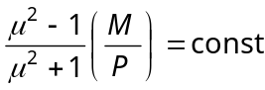. (12)
- (a) Define wave guide. (2)
(b) ‘‘A wave guide is a high pass filter’’ comment on the validity of this statement. (3)
(c) What are TE, TM, and TEM modes? (3)
(d) Derive expression for field about cut off for a rectangular wave guide in TE model and also in TM model. (12)
- (a) What are called Alfren waves? (3)
(b) Derive the general equation for the velocity of magneto hydrodynamic waves and find the solution when
(i) propagation vector is 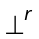 to Alfren velocity.
(ii) propagation vector is 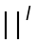 to Alfren velocity.
(10)
(c) In the photosphere, there are 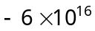 hydrogen atoms per cm³. Assuming the field in photosphere to be 1000 gauss, calculate the phase velocity of Alfren waves. (7)
- (a) Obtain the boundary conition by the electromagnetic field vectors, ‘D’. (8)
(b) Obtain the boundary condition for magnetic induction ‘B’. (6)
(c) Obtain the boundary condition for electric intensity vector ‘E’. (6)
- (a) What is molar polarization? (3)
(b) Explain the polar dielectrics. (5)
(c) Obtain clausius-mossotti equation. (12)
- (a) Discuss the conditions for existence of a plasma. (4)
(b) Write about coherence and incoherence of scattered light. (6)
(c) An air filled rectangular wave guide has cross sectional dimensions a = 10 cm and b = 5 cm. At frequencies below 5 GHz what modes of TE and TM type, will this guide transmit? (10)
——————
DE–7655
15
DISTANCE EDUCATION
M.Sc. (Physics) DEGREE EXAMINATION, DECEMBER 2009.
NUMERICAL METHODS AND PROGRAMMING
(2008 onwards)
Time : Three hours Maximum : 100 marks
Answer any FIVE questions.
Each question carries 20 marks.
- (a) What are the basic data types in C? (5)
(b) Explain Hierarchy of operators in C. (5)
(c) Explain the use of condinal operator with examples. (10)
- (a) Give the general format of two way branching statement. Compare this with multiway branching.
(5)
(b) What are the looping statement in C. Explain each of them with examples. (10)
(c) Discuss any five library function with example. (5)
- (a) What is function prototype? (4)
(b) Compare passing parameters by values and by reference with detailed examples. (10)
(c) How memory is allocated using pointers? (6)
- (a) Explain all the storage classes available in C. (10)
(b) What is a structure? How a structure is declared. (5)
(c) Compare union with structures. (5)
- (a) Derive the formula for Newton Raphson method. (4)
(b) Discuss advantages and disadvantages of four itrative methods. (4)
(c) Find a real root of the equation 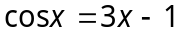 correct to 3 decimal places by using iteration method. (12)
- (a) Explain Gauss elimination method. (5)
(b) Use Gauss elimination method to solve the following equations : (8)
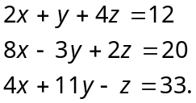
(c) Using the principle of least squares, fit an equation of the form 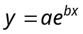 to the following data : (7)
x : 1 2 3 4
y : 1.65 2.70 4.50 7.35
- (a) How Euler method is modified? (5)
(b) Dividing the range into 10 equal parts, find the approximate values of 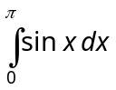 by Trapezoidal rule. (10)
(c) Discuss the principle of Simpson’s rule. (5)
- (a) Give examples for formated input and output. (5)
(b) Write the program to find factorial of a number using recursion function. (8)
(c) Using Euler’s method solve the equation 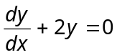, 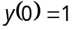 taken 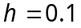 and obtain 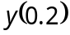. (7)
–––––––––––––––

